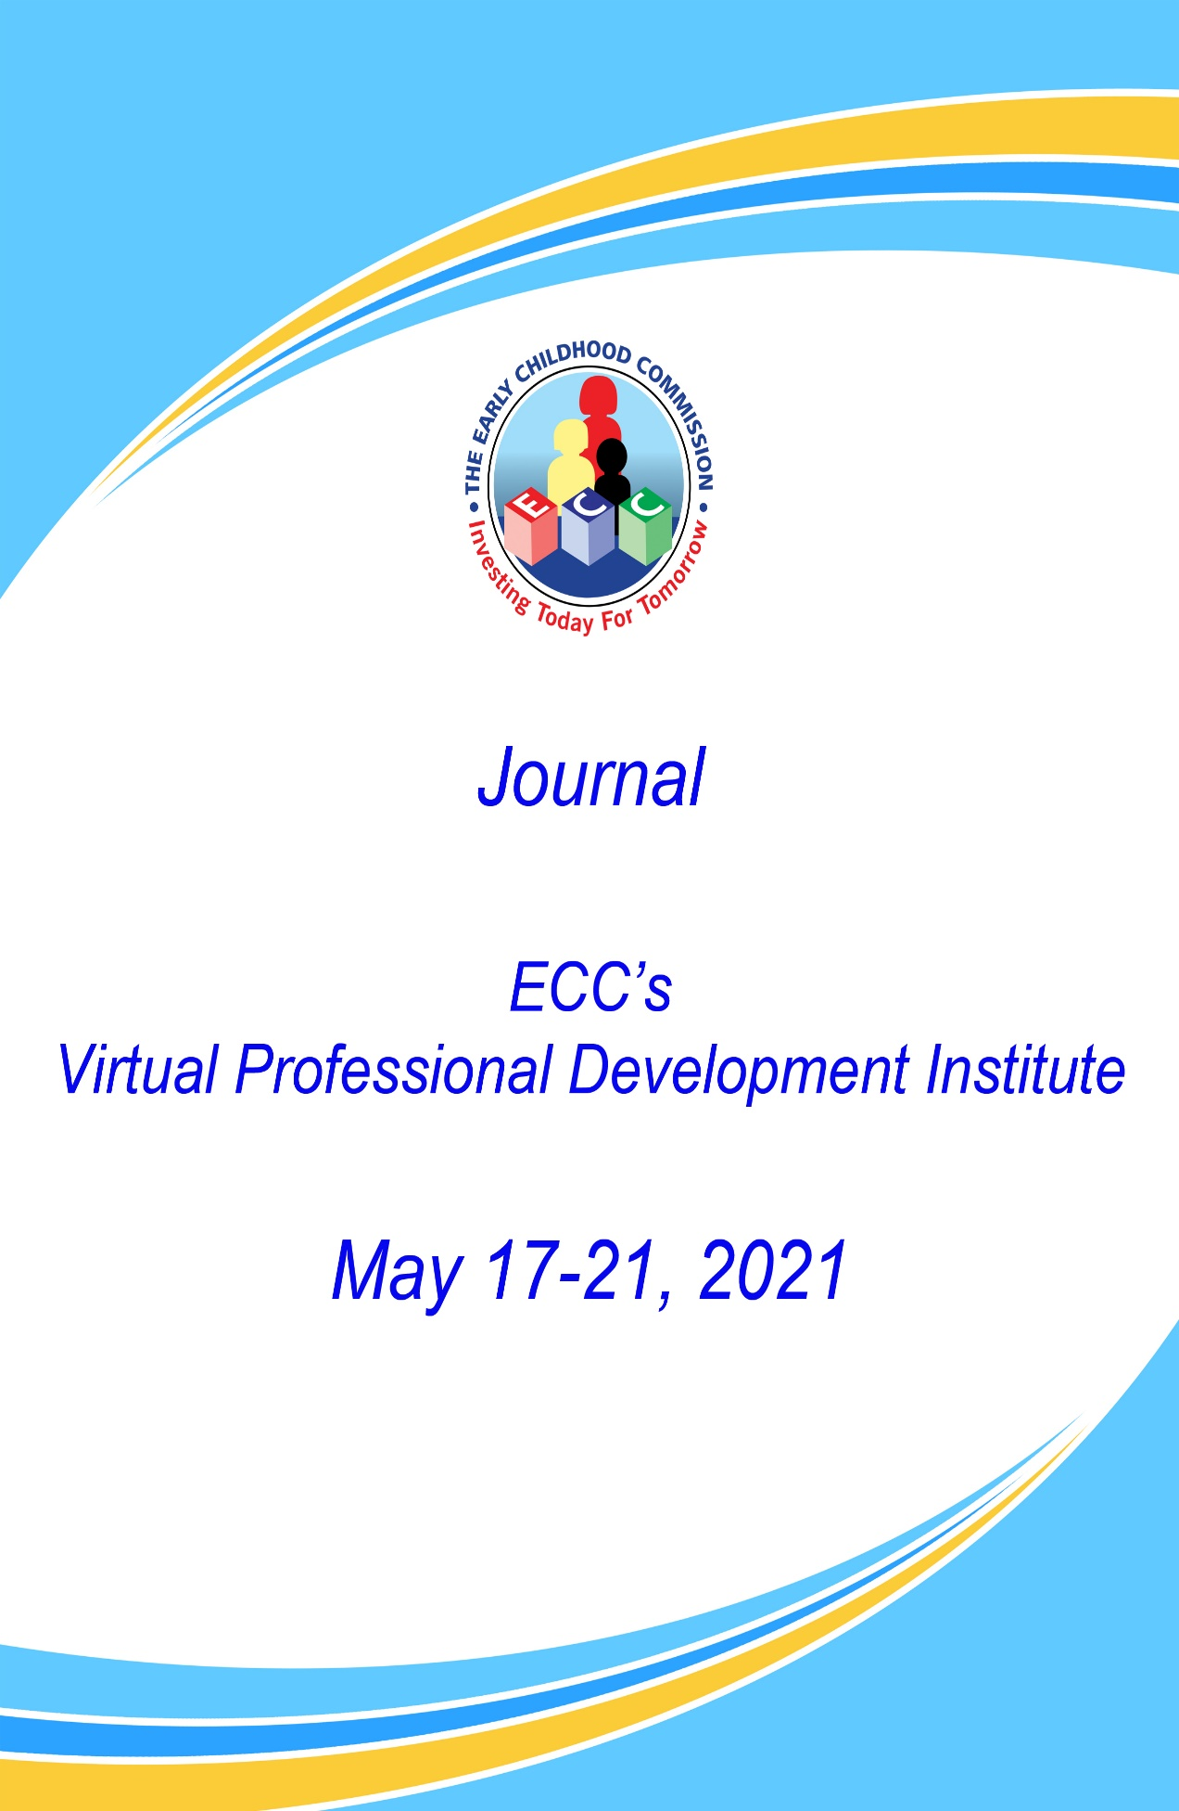

Theme: “Through a transformational learning environment our children are inspired to be creative”

Name:____________________________________________

Date:______________________________________________

Name of Early Childhood Institution: _______________________

Vision:_______________________________________________

MAKING THE MOST OF THE PROFESSIONAL DEVELOPMENT INSTITUTE

Dear Participant, this journal was created especially for you to support your learning experience at our virtual professional institute 2021. Please take a few minutes to familiarize yourself with the content. You will be able to utilize this journal throughout the five days by setting your intentions, taking notes and reflecting on your conference experiences.

tips for making the most of a virtual conference (Kramer, 2020)
Before
- Organize your session schedule. With more flexibility, it’s critical to plan ahead and optimize what sessions you want to see. Maximize your time and learning by reviewing and selecting topics and sessions in advance.
- Prioritize your time. The truth is, multitasking isn’t that productive. Focus on making the best use out of your time by being truly present. Set reminders for sessions so you don’t miss something important.
- Minimize distractions. Interruptions happen. Set yourself up in a quiet space. Be sure to silence your phone, block off your calendar, and put a “Do not Disturb” message on, so you can fully focus.
- Familiarize yourself with the tools. There’s nothing worse than missing something because of faulty technology. Be sure to test your audio and ensure a strong wifi connection.
During
- Be an active participant. Plan to participate beyond listening. Take notes. Get active on social media by using conference hashtags, live chats, and other tools to connect.
- Build your virtual community. A virtual conference allows for you to engage with other participants in meaningful ways. For example, expand your network by sharing contact information, where possible.

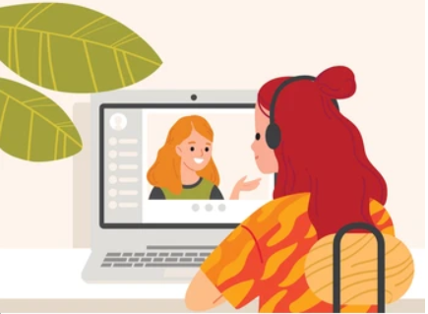
After
- Take advantage of replays. Catch any recorded sessions you may have missed. Debrief with fellow attendees and peers. Keep the conversation going by sharing key takeaways.
Bonus tip: Don’t forget to have fun. You’re here to learn, connect and, most importantly, have some fun!

Setting your intention

- Why did you register for ECC’s Professional Development Institute 2021?
________________________________________________________________________________________________________________________________________________________________________________________________________________________________________________________________________________________________________________________________________________________________________________________________________________________________________________________________________________________________________________________________________________________________________

- What are your expectations for this five day event?
________________________________________________________________________________________________________________________________________________________________________________________________________________________________________________________________________________________________________________________________________________________________________________________________________________________________________________________________________________________________________________________________________________________________________

- How do you plan to share your learning from this professional development institute?

________________________________________________________________________________________________________________________________________________________________________________________________________________________________________________________________________________________________________________________________________________________________________________________________________________________________________________________________________________________________________________________________________________________________________

Day 1 - Monday, May 17, 2021

Notes:

__________________________________________________________________________________________________________________________________________________________________________________________________________________________________________________________________________________________________________________________________________________________________________________________________________________________________________________________________________________________________________________________________________________________________________________________________________________________________________________________________________________________________________________________________________________________________________________________________________________________________________________________________________________________________________________________________________________________________________________________________________________________________________________________________________________________________________________________________________________________________________________________________________________________________________________________________________________________________________________________________________________________________________________________________________________________________________________________________________________________________________________________________________________________________________________________________________________________________________________________________________________________________________________

My top three takeaways from today’s sessions are:

- ____________________________________________________________________________________________________________________________________________________________________________________________________________________________________________________________________________________

- ____________________________________________________________________________________________________________________________________________________________________________________________________________________________________________________________________________________

- ____________________________________________________________________________________________________________________________________________________________________________________________________________________________________________________________________________________

Day 2 - Tuesday, May 18, 2021

Notes:

__________________________________________________________________________________________________________________________________________________________________________________________________________________________________________________________________________________________________________________________________________________________________________________________________________________________________________________________________________________________________________________________________________________________________________________________________________________________________________________________________________________________________________________________________________________________________________________________________________________________________________________________________________________________________________________________________________________________________________________________________________________________________________________________________________________________________________________________________________________________________________________________________________________________________________________________________________________________________________________________________________________________________________________________________________________________________________________________________________________________________________________________________________________________________________________________________________________________________________________________________________________________________________________

My top three takeaways from today’s sessions are:

  - ____________________________________________________________________________________________________________________________________________________________________________________________________________________________________________________________

  - ____________________________________________________________________________________________________________________________________________________________________________________________________________________________________________________________
  - ____________________________________________________________________________________________________________________________________________________________________________________________________________________________________________________________

Day 3 - Wednesday, May 19, 2021

Notes:

__________________________________________________________________________________________________________________________________________________________________________________________________________________________________________________________________________________________________________________________________________________________________________________________________________________________________________________________________________________________________________________________________________________________________________________________________________________________________________________________________________________________________________________________________________________________________________________________________________________________________________________________________________________________________________________________________________________________________________________________________________________________________________________________________________________________________________________________________________________________________________________________________________________________________________________________________________________________________________________________________________________________________________________________________________________________________________________________________________________________________________________________________________________________________________________________________________________________________________________________________________________________________________________

My top three takeaways from today’s sessions are:

  - ____________________________________________________________________________________________________________________________________________________________________________________________________________________________________________________________

  - ____________________________________________________________________________________________________________________________________________________________________________________________________________________________________________________________
  - ____________________________________________________________________________________________________________________________________________________________________________________________________________________________________________________________

Day 4 - Thursday, May 20, 2021

Notes:

__________________________________________________________________________________________________________________________________________________________________________________________________________________________________________________________________________________________________________________________________________________________________________________________________________________________________________________________________________________________________________________________________________________________________________________________________________________________________________________________________________________________________________________________________________________________________________________________________________________________________________________________________________________________________________________________________________________________________________________________________________________________________________________________________________________________________________________________________________________________________________________________________________________________________________________________________________________________________________________________________________________________________________________________________________________________________________________________________________________________________________________________________________________________________________________________________________________________________________________________________________________________________________________

My top three takeaways from today’s sessions are:

  - ____________________________________________________________________________________________________________________________________________________________________________________________________________________________________________________________

  - ____________________________________________________________________________________________________________________________________________________________________________________________________________________________________________________________
  - ____________________________________________________________________________________________________________________________________________________________________________________________________________________________________________________________

Day 5 - Friday, May 21, 2021

Notes:

__________________________________________________________________________________________________________________________________________________________________________________________________________________________________________________________________________________________________________________________________________________________________________________________________________________________________________________________________________________________________________________________________________________________________________________________________________________________________________________________________________________________________________________________________________________________________________________________________________________________________________________________________________________________________________________________________________________________________________________________________________________________________________________________________________________________________________________________________________________________________________________________________________________________________________________________________________________________________________________________________________________________________________________________________________________________________________________________________________________________________________________________________________________________________________________________________________________________________________________________________________________________________________________

My top three takeaways from today’s sessions are:

  - ____________________________________________________________________________________________________________________________________________________________________________________________________________________________________________________________

  - ____________________________________________________________________________________________________________________________________________________________________________________________________________________________________________________________
  - ____________________________________________________________________________________________________________________________________________________________________________________________________________________________________________________________

Persons I met at ECC’s Professional Institute 2021 who I would like to connect with further are:

Name: ____________________________________

Organization: ____________________________________

Contact Information: _____________________________________

Name: ____________________________________

Organization: ____________________________________

Contact Information: _____________________________________

Name: ____________________________________

Organization: ____________________________________

Contact Information: _____________________________________

Name: ____________________________________

Organization: ____________________________________

Contact Information: _____________________________________

Thank you Remarks from the Executive Director

On behalf of the Early Childhood Commission, I would like to extend a resounding thank you to all our participants who took the time to attend our Professional Development Institute 2021. It is our hope that you had an astronomical learning experience and that we were able to strengthen your confidence to apply the wealth of knowledge and skills garnered. It was truly a pleasure having you. Remember, “it is easier to build strong children than to repair broken men”. Thank you.

The Early Childhood Commission Quality Policy Statement

The Early Childhood Commission is committed to provide integrated and coordinated delivery of quality early childhood programmes and services within a healthy, safe and nurturing environment consistent with legal and regulatory requirements. We are committed to continual improvement in meeting or exceeding customer expectations through a highly efficient, motivated and performance-driven team.

SPONSORS

CHASE FUND

Jamaica Diaspora Taskforce Action Network

